|  |
| --- |
| Testing list Class |

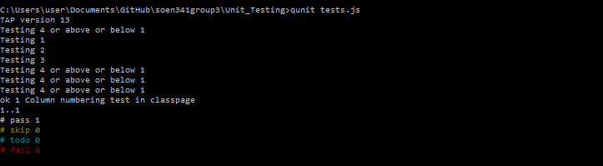

|  |
| --- |
| Testing TA function |

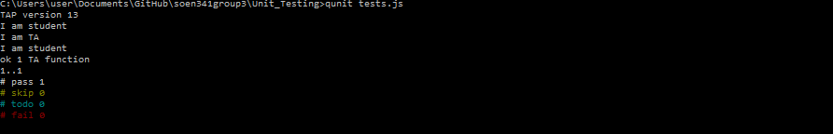

|  |
| --- |
| Testing Date function result in overflow..... |

